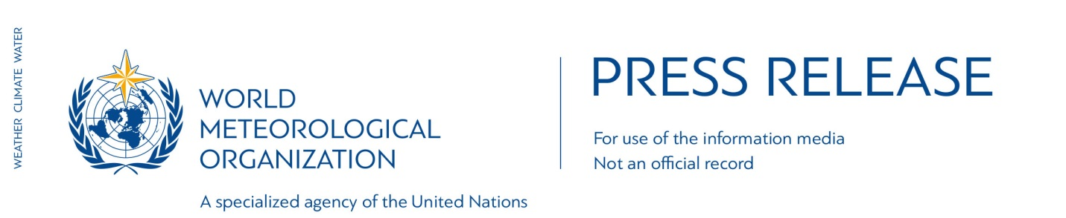

No. 5/2016

Climate Change Sets New Records
Planet sends powerful message on Paris Agreement

21 April 2016 (WMO) _ A prolonged run of record global temperatures and extreme weather, the rapid melting of Arctic ice, and widespread bleaching of ocean coral reefs underline the urgent need to sign and implement the Paris Agreement on climate change, according to the World Meteorological Organization (WMO).

WMO Secretary-General Petteri Taalas said that 2016 has so far overshadowed even the record-breaking year of 2015.

“The magnitude of the changes has been a surprise even for veteran climate scientists. The state of the planet is changing before our eyes,” said Mr Taalas.

“If the international community acts immediately to halt the rise in CO2 emissions, we can still hope to stabilize global warming over the coming decades. If not, the negative consequences will last for tens of thousands of years.”

“WMO welcomes news that a record number of governments will sign the historic climate agreement on 22 April. WMO and the world’s national weather services will support the rapid implementation of the Paris Agreement and the adoption of climate change adaptation measures,” said Mr Taalas.

It is important to pay attention to adaptation, since the negative trend of growing number of weather related disasters is expected to continue at least until the latter half of this century. There is a need to invest more in modern disaster early warning and climate services especially in developing countries.

WMO is working on an Integrated Global Greenhouse Gas Information System that will allow governments to identify and closely monitor specific sources of national emissions in order to craft more targeted measures for limiting them.

It is also giving top priority to developing reliable and accessible climate information products that the energy sector can use to fine-tune the management of renewables sources such as solar and wind power and increase energy efficiency.

Impacts of Climate Change

A powerful El Niño has contributed to the high temperatures and extreme events witnessed in recent months. However, the main driver is long-term human induced climate change. Each of the past several decades has been significantly warmer than the previous one. The period 2011–2015 was the hottest on record, as was the year 2015.

The first three months of 2016 also broke temperature records, by the biggest margin ever measured, according to preliminary data from the U.S National Oceanic and Atmospheric Administration, NASA and the Japan Meteorological Agency.

Other worrying developments so far this year include:

- Concentrations of carbon dioxide in the global atmosphere reached 403.28 parts per million in February 2016, according to NOAA.

- The maximum Arctic sea ice extent, recorded in March 2016, was the lowest on record for the second straight year, according to the U.S. National Snow and Ice Data Center which said it was a “warm crazy winter in the Arctic.”

- An unusually early and large Greenland ice sheet melt occurred in the week of 11 March, beating by a month the previous record of more than 10% of the ice sheet melting. “We had to check that our models were still working properly,” said the Danish Meteorological Institute.

- Ice breakup in the Beaufort Sea north of Alaska was unusually early.

- A devastating coral bleaching event which began in October 2015 worsened in 2016 because of record sea surface temperatures. Australia’s iconic Great Barrier Reef was among the worst affected.

- Drought triggered by El Niño caused widespread food insecurity and hydroelectric power shortages in the Horn of Africa and southern Africa, whilst parts of South America – including Argentina, Paraguay and Uruguay – suffered serious flooding.

Adaptation Tools

Because of past and present emissions, there will be more hot days, warm nights and heatwaves. This will affect public health and put a strain on societies. But health risks related to heat can be reduced through multi-hazard early warning systems that provide timely alerts to decision-makers, health services and the general public.

Integrated drought management is needed to deal more proactively with droughts and provide decision-makers with guidance on effective policies and land management strategies.

Climate change is also increasing the risk of heavy rains and floods. Progress is being made in the use of impact-based warnings, which describe the physical impacts of a hazard, rather than difficult-to-interpret measurements such as “100 km/h wind” or a “3m sea-surge.” This helps disaster managers take timely action to save lives and property.

Notes for Editors
Details about the Paris Agreement on climate change are available here
Details about the April 22 signing ceremony in New York are available here

The World Meteorological Organization is the United Nations System’s authoritative voice on Weather, Climate and Water
www.wmo.int

For further information contact: Clare Nullis, Media Officer. Email cnullis@wmo.int. Telephone +41227308478 or Mobile +41797091397

